Credit Profile Screens for Kmart from Bloomberg:

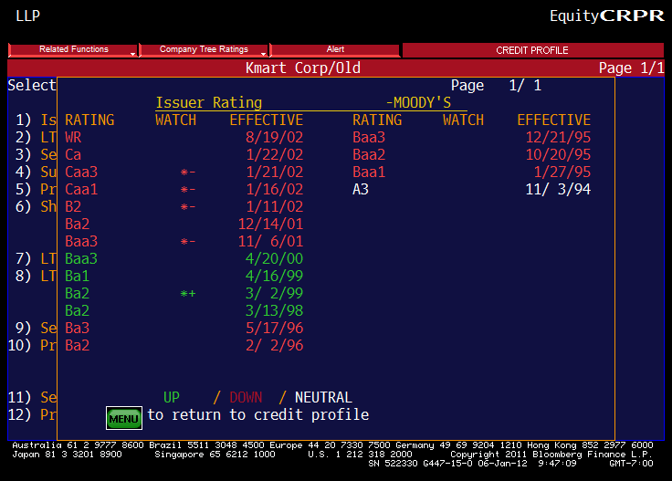

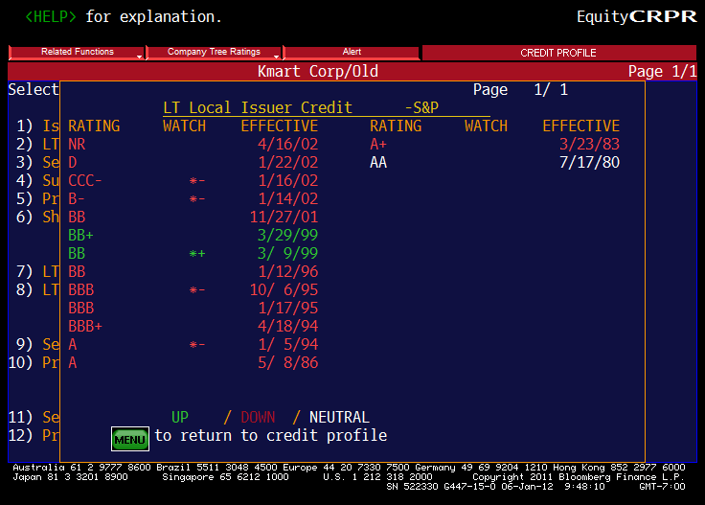

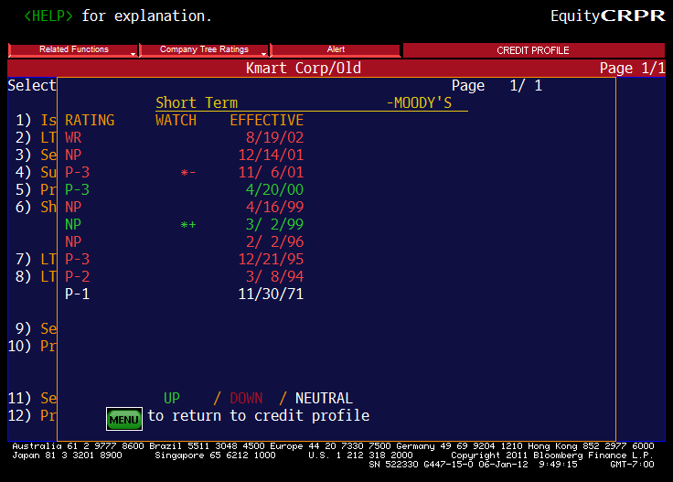

Kmart filed Chapter 11 bankruptcy on January 22, 2002. Note that Moody’s rated Kmart as Investment Grade between April 20, 2000, and December 14, 2001. Note the flurry of downgrading activity in January 2002.

Note too the fall from grace, as from 1971 through 1994 Kmart had access to Tier-1 commercial paper.

Kmart did successfully emerge from Chapter 11 in May 2003 (after having spent 16 months operating ``under’’ Chapter 11). Edward Lampert was Board Chairman.

Kmart merged with Sears, Roebuck, and Company on November 17, 2004.

Our motivations for looking at this case to start off our analysis of credit risk:

- Most models of credit risk treat bankruptcy as death. This case highlights that that is often far from the truth.
- Bankruptcy is a period of renegotiation. Note that covenants are important, but not necessarily binding in the event of bankruptcy.
- Note that the Credit Markets have a special vehicle: Debtor in Possession (DIP) financing to allow the enterprise to continue in business.
-→ General Electric Finance had been the major player in DIP financing prior to the financial crisis. They seem to have vacated the field as the crisis unfolded, so hedge funds have jumped in to the void.

Note too another player in the fixed income world, where lending and equity blend: Vulture Finance.

A big part of credit risk modeling is recovery-conditional on default. Note in the case (Exhibit 8) that the bond holders receive about 14% of the face value of their bonds.

